

Exci Trading Strategy
A Quantitative Approach to Leveraged ETF Position Trading

Version 2.4 | March 2026

+6,028%  Since 2020 | 94%  CAGR | 10.3x  vs TQQQ B&H | -32%  Max Drawdown

Executive Summary
The Exci Trading Strategy is a systematic, rules-based approach to trading leveraged Nasdaq ETFs (TQQQ/SQQQ) using a combination of trend identification, extension-based position sizing, and exhaustion signals for tactical shorts.
Exci delivers superior risk-adjusted returns with dramatically lower drawdowns. The strategy achieves 5x higher returns with 61% less drawdown than buy-and-hold.

Performance Since 2020
Metric | Exci v2.4 | TQQQ B&H | Advantage
Total Return | +6,028% | +498% | 10.3x better
CAGR | 94% | ~33% | +61% annually
Max Drawdown | -32% | -81% | 61% less pain
Sharpe Ratio | 1.76 | 0.76 | 2.3x better
$100K Investment | $6.13M | $598K | 10.3x more

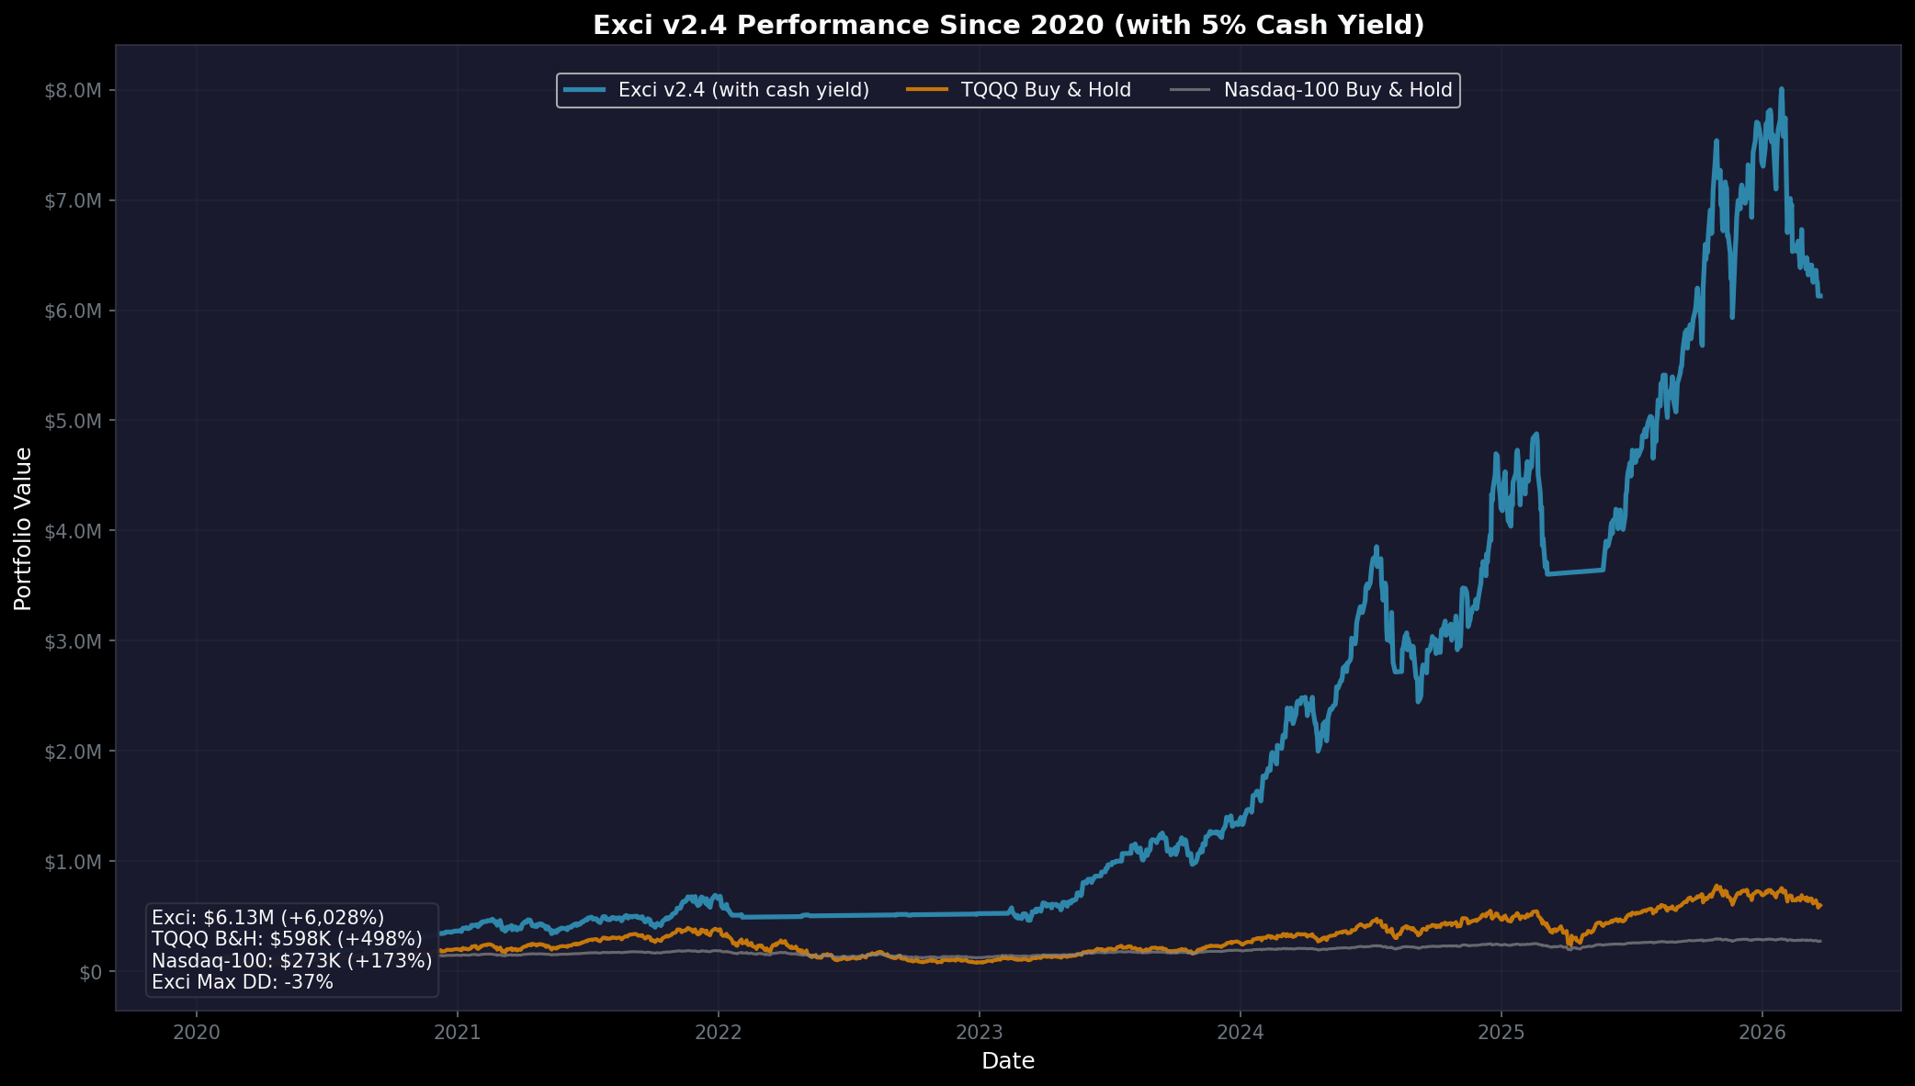
Figure 1: Equity Curve Comparison (2020-Present)

Hypothetical Historical Performance (1985-Present)
Using simulated 3x daily returns before TQQQ/SQQQ existed, we can backtest the strategy to 1985. Exci outperforms the Nasdaq 100 by 383x over this 40-year period by avoiding the catastrophic crashes of 2000-2002 and 2008-2009.

Metric | Exci v2.4 | NDX B&H
Final Value ($100K) | $8.3B | $22.4M
CAGR | 32% | 12%
Max Drawdown | -71% | -83%
Outperformance | 383x | -

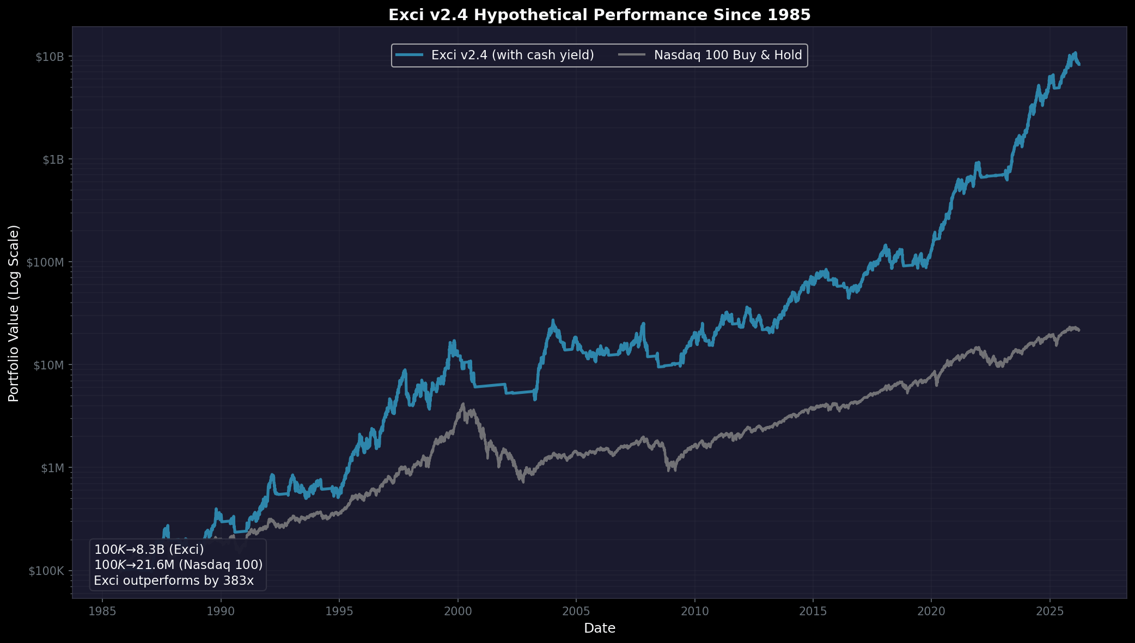
Figure 2: Hypothetical Equity Curve (1985-Present, Log Scale)

Drawdown Analysis
The strategy's maximum drawdowns compare favorably across all periods. By moving to cash during bear markets, Exci avoided the catastrophic crashes that would have destroyed a leveraged buy-and-hold portfolio.

Period | Exci Max DD | TQQQ Max DD | Reduction
Since 2020 | -32% | -81% | 61% less
Since 2000 | -71% | TQQQ wiped out | Exci survived
Since 1985* | -71% | -100% | Avoided wipeout
*Pre-2010 data uses simulated 3x daily returns

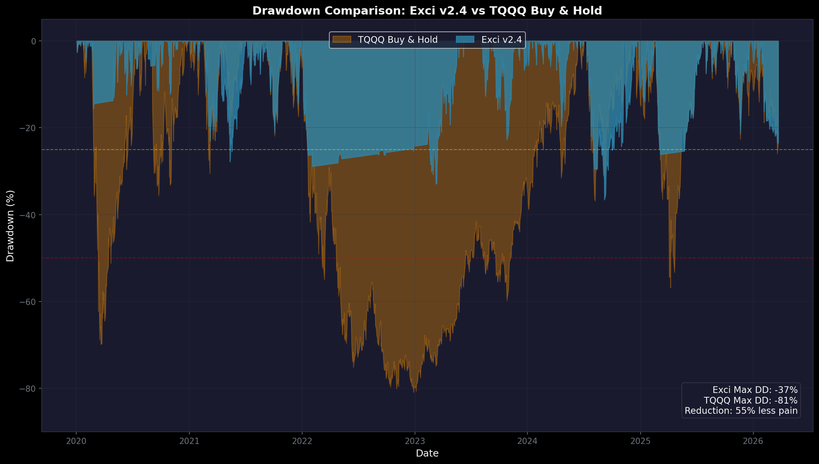
Figure 3: Drawdown Comparison (2020-Present)

The Honest Question: Could you watch $10M drop to $1.9M and NOT sell?
Exci delivers returns you can actually keep — with dramatically lower drawdowns.

How The Strategy Works
Every day, Exci makes three systematic decisions:

- Read the Market: Is it trending up, overextended, or uncertain?
- Choose the Action: TQQQ (bullish), SQQQ (exhausted), or Cash (defensive)
- Size the Position: Scale with conviction — larger when signals are strong
Understanding TQQQ & SQQQ
TQQQ delivers 3x the daily return of the Nasdaq-100. SQQQ delivers -3x (inverse) the daily return.
Amplified Swings:
- A 10% market correction becomes a 30% TQQQ drawdown
- A 33% bear market (like 2022) becomes an 80%+ TQQQ crash
- The leverage cuts both ways — fast
SQQQ vs Cash — When Each Is Used
Situation | Action | Why
Bear market / uncertainty | Cash | Defensive — avoid losses, earn 5% yield
Exhaustion signals triggered | SQQQ | Offensive — profit from imminent pullback
Cash protects. SQQQ profits from declines.
Cash Earns Too
When Exci moves to cash, your money isn't idle. Most brokerages offer money market sweep accounts earning 4-5%+ APY. Our backtests include a 5% annual cash yield. Even when sitting out, your capital is working for you.

Why Exci Works
- Avoids Catastrophic Losses — Cash during 2000, 2008, 2022 crashes
- Captures Bull Trends — Full exposure during uptrends
- Reduces Overheated Risk — Position scaling at extensions
- Tactical Shorts Add Alpha — Exhaustion shorts profit from pullbacks
- Cash Earns Too — 5% APY from money market sweep
Conclusion
The Exci Trading Strategy demonstrates that systematic, rules-based trend following with intelligent position sizing can significantly outperform buy-and-hold approaches to leveraged ETF investing.
The strategy is not a "get rich quick" scheme. It requires discipline to hold through volatile periods, trust the system during underperformance, and accept that some drawdowns are unavoidable.
For investors who can maintain this discipline, Exci offers a compelling approach to leveraged ETF trading.

This document is for educational purposes only and does not constitute financial advice.
Past performance does not guarantee future results. Leveraged ETFs carry significant risk.
Methodology: TQQQ/SQQQ performance is simulated using 3x daily returns of the Nasdaq-100 index, which allows backtesting to 1985. Actual ETF returns may differ due to expense ratios (0.95% annually) and tracking differences. The simulation does not deduct expense ratios, meaning TQQQ buy-and-hold figures are slightly inflated compared to actual TQQQ.

Author: Ted Ruscha | Strategy Version: 2.4 | March 2026
© 2026 Exci. All rights reserved. Unauthorized reproduction or distribution prohibited.

